Urban Legends of Volleyball
We’ve all heard these, and maybe you believe some of them. But you need to know what the rule or casebook actually says and correctly communicate the correct rule. Equally important, you must be aware of the differences in the rule codes when you are refereeing. Here are 20 common misstated rules that participants and officials can’t seem to let go of.
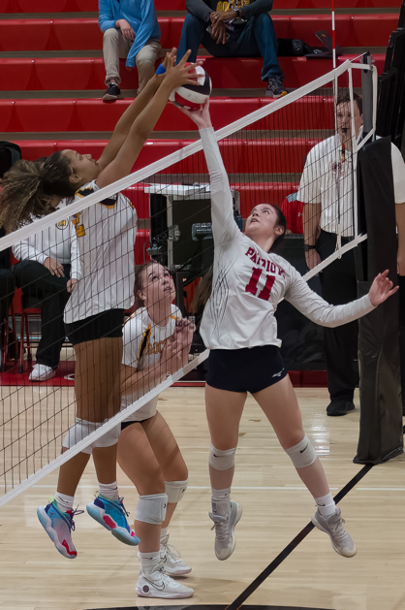
Legend 1. But my setter was trying to set the ball…
The ball in the photo is in the plane of the net and above the height of the net. Both teams have the right to play it. However, if #11 is a back row player, she is committing a fault, most likely an illegal block, because the contact appears simultaneous with the blocker on the left. That said, if in the judgment of the R1, #11 contacted the ball first, an illegal attack could also be an appropriate call. This is true in all rule codes (USAV, NCAA, and NFHS)
Legend 2. But she is a blocker…
While USAV 14.3 allows a team to block a ball entirely on the opponent’s side of the net once the attack is complete, a player is never allowed to attack a ball if the contact is not within his/her own playing space (11-1-2). If a blocker swings at a ball and attacks it on the opponent’s side, it is a fault. Conversely, remember that a ball can be blocked with only one arm. Know the position of the ball and call what you see.
Legend 3. Now you have to go in…
A player enters the substitution zone. The R2 blows the whistle and signals for the substitution. The head coach does not want to substitute. The team is not required to complete the substitution, but will be awarded a delay if the substitution request is withdrawn. Be sure the coach is aware of the options in this fairly common occurrence.

Legend 4. But the number is contrasting…
This jersey number is illegal under rule 4.3.3.1.d. Unfortunately, unlike other rule codes, there is no remedy (no administrative sanction) for this illegal jersey under USAV rules.
Legend 5. But the libero was behind the attack line… According to rule 19.3.1.2, the libero can never attack a ball from anywhere (including the playing court or free zone) if the ball is entirely above the height of the net at the moment of contact. This action becomes a fault when the ball crosses the net or is legally contacted by an opponent.
Legend 6. Hey, the Libero was in the front zone when she attacked (dumped with finger action) that ball…
Yes, the libero can do that as long as the ball is not entirely above the height of the net at the moment of contact.
Legend 7. But the player she set was behind the attack line…
Additionally, the libero can never set a ball from in front of the attack line with finger action if the set results in a completed attack from anywhere on the court with the ball above the height of the net at the moment of contact. This action becomes a fault when the ball crosses the net or is legally contacted by an opponent.
Legend 8. Hey, she netted…
Unlike the NFHS rule code, it is not a net fault when a player touches the net or net cables outside the antenna while the ball is in play (11.3.2). Additionally, the player must be playing the ball (11.3.1) to commit a net fault. So, yes, there could be net contact that is not a fault.
Legend 9. She’s under…
Additionally, USAV 11.2.2.2 allows a player to touch the floor across the centerline with any body part, provided that any body part is in contact with or directly above the centerline and there is no interference with the opponent. This action must also not present a safety hazard to the opponents.
Legend 10. Don’t start the clock…
The coin toss before a deciding set is only for serve or receive, since we are not switching sides. Unlike other rule codes, we do not wait until the toss is complete to start the clock (USAV 18.1).
Legend 11. It’s a dead ball, so all coaches can stand…
USAV 5.2.3.4 and 5.3.1 allow only the head coach and one assistant to stand at all times, regardless of whether the ball is in play or not.
Legend 12. I protest, there were no line judges at the start of the set…
This is a legitimate protest. It does not matter if the lack of line judges did not influence the outcome of the play. Rule 22.1 requires line judges. If a coach protests, the set must be restarted.
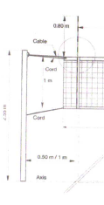
Legend 13. The antennas are on the wrong side…
Diagram 3 shows that the antenna must be directly over the outside edge of the sideline. Rule 2.4 does not specify which side of the net each antenna should be located.
Legend 14. The R1 always checks the net height, and the R2 checks the ball pressure…
This isn’t a thing. The referees must complete these checks, but it doesn't matter who does what. Proper and efficient teamwork is the only requirement.
Legend 15. Spectators can sit or stand in the warm-up area as long as they are further from the bench than the last girl standing in the warm-up area.
USAV 1.4.5 doesn’t specify an end to the warm-up area. Keep spectators out of it.
Legend 16. You can sanction a player with a yellow card in set 1, then sanction her coach with a yellow card in set 2
USAV 21.1 says each team may receive only one yellow card per match.
Legend 17. If you disqualify a player or a coach, the opponent gets a point.
For both expulsions and disqualifications, there are no additional consequences beyond leaving the court or the playing area.
Legend 18. If a player’s jersey grazes the net, you must call a net fault.
Well, technically yes, but the art of officiating allows for no fault if the jersey (and only the jersey) lightly grazes the net.
Legend 19. Second team hits are just like first team hits now…
Sure, both team hits can have multiple contacts with the body during one attempt to play the ball, but the multiple-contact second-team hits must be touched next by a teammate. A multiple-contact first-team hit can be sent to the opponent.
Legend 20. LJ says the ball was in; I saw it out. Let’s do a replay…
This might seem like the fair thing to do, but the rules give specific times a replay can be awarded (double faults, low-hanging overhead obstructions, interfering objects, inadvertent whistle, etc.), and this isn’t one of them. The rules require the first referee to render a decision when members of the officiating corps do not agree (23.3.2.3). Additionally, if officials believe there might have been a fault, but are unsure, a replay is not allowed.

